Dream Team

## Team A

## 02/05/2021 - Milestone 1

**Group Roles:**

1. **Janiece Campbell**: Creative Director, Flex Developer
2. **Ferris DeHart**: Frontend Developer, Interactive Testing Specialist
3. **Seth Richard**: Scrum Master, Backend Developer
4. **Ferol Schoonmaker**: Project Manager, Backend Developer
5. **Nick Settoon**: Frontend Developer, Database Specialist

**Contribution**

1. **Janiece Campbell**: 100%
2. **Ferris DeHart**: 100%
3. **Seth Richard**: 100%
4. **Ferol Schoonmaker**: 100%
5. **Nick Settoon**: 100%

**User Stories:**

1. The user will be prompted to sign into the website. The user will click on login if they have an account already. If the user does not have an account they will click sign up.
2. If the user selects login they will be given a username and password field to fill out. If the user fails to login after 3 tries they will be asked if they need to reset their password.
3. If the user selects to reset their password, an email will be sent to the email address associated with the user’s account and they will be given a temporary password. After using the temporary password the user will be prompted to set a new password.
4. If the user selects sign up they will be given a username, email, password, confirm password, and EULA field. The user will put the email they wish to associate the account with in the email field. If the email is already in use by another account on the website the user will be prompted to use a different email. The user will put their desired username into the username field. If the username is already being used by another account on the website the user will be prompted to enter in a new username. The user will put their desired password into the password field, they will then re-type the password in the confirm password field. If the two fields do not have identical contents the user will be prompted to retype the password into the confirm password field. The user will confirm that they agree to the EULA that confirms that they understand the fees associated with the service as outlined by the project customer.
5. When the user has created an account they will be given a name field, an address field, a birthdate field, a phone number field, and a credit card number field, cardholder field, c.c. expiration date field, a c.c. security number field and a billing address checkbox. The user will fill out the name field with their name, the address field with their address, the birthdate field with their birthday, the phone number field with their phone number, the user will then fill out the credit card number field with a credit card number, the cardholder field with the name associated with the credit card, and the expiration date field with the cards expiration date in mm/yyyy order. The user will put in the three numbers on the back of the credit card into the security number field. If the address the user listed in the address field is the same address associated with the credit card number the user will check the billing address checkbox. If the user does not check the billing address checkbox they will be prompted to fill out another address field with the address associated with the credit card.
6. When the user is signed in they will be able to select a button labeled ‘Rent Bike.’ If the user presses the ‘Rent Bike’ button they will be prompted to scan the barcode on the bike, this will then ask for confirmation and display the hourly cost associated with the rental and a statement that says, “If the bike is not returned, the customer’s credit card will be charged $500. If a bike is damaged, the customer will be charged $200 for the damage, depending on the damage.” The user can cancel the rental at any time, however if the user confirms the rental, the current timestamp will be tracked and sent to the database. Once the user confirms the bike will be released from the dock and they can begin biking. After confirming, there will be a prompt to rent another bike, which they can easily close.
7. Once the user replaces the bike in the rack, the rack locks the bike. Then the rack would tell the server to end the rental, which would notify the user that the rental period is over. The user would get an email receipt of the transaction.
8. Managers can log in from the same landing page as the client using a special, preset login. From the admin level site, they can choose to see/generate current and previous weekly reports. Current bike requests are also displayed, and the admin can choose to accept or deny based on card validity (or some other reason).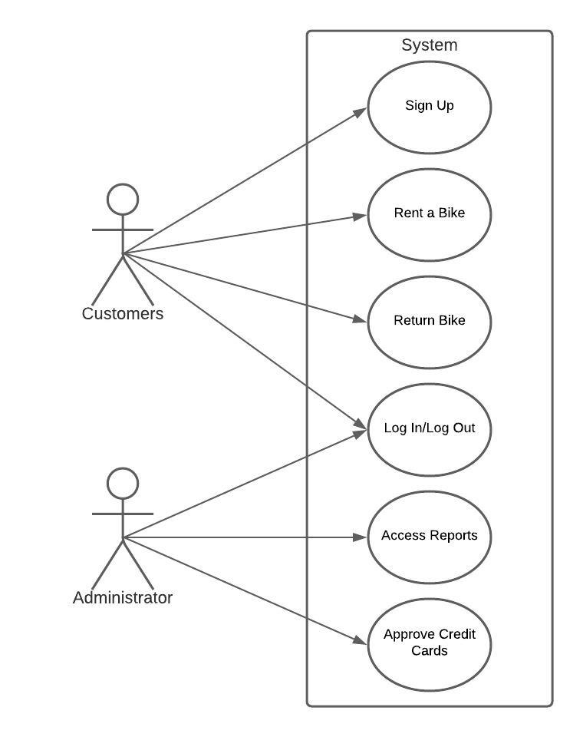

**Use cases:**

1. Administrator User:
   * Accesses weekly reports
   * Approves credit cards
2. Customer User:
   * Rent a bike
   * Log In
   * Log out
   * Sign up

**Project Backlog:**

1. Create the foundation of the website
2. Create a database to store user information, and bike information
   * Able to store private information (credit card information, passwords, and addresses)
3. Create a login/signup feature for the website
4. Create a rent-a-bike feature for the website

* Able to process payment
* Able to input different bike numbers
* Able to input different bike docks
* Able to calculate correct payment

1. Create a report system accessible by Mr. Dowling

**Backlog for First Sprint:**

1. Filter user stories into actionable items
2. Delegate actionable items into frontend or backend categories
3. Get site live on the production server